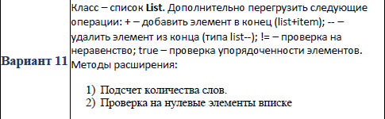

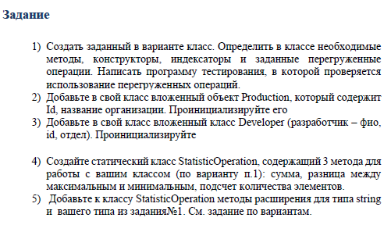

text = text.Trim(new char[] { ',', '.' });

string[] textArray = text.Split(new char[] { ' ' });

Console.WriteLine("words num: " + textArray.Length);

string longestWord = "";

for (int i = 0; i < textArray.Length; i++)

{

if (textArray[i].Length >= longestWord.Length)

longestWord = textArray[i];

}

Console.WriteLine("longest: " + longestWord);

while (text.Contains(" "))

text = text.Replace(" ", " ");

Console.WriteLine("w/o unwanted spaces: " + text);